Enhancing Privacy and Accuracy in Probe Vehicle-Based Traffic Monitoring via Virtual Trip Lines

A PROJECT REPORT

in the partial fulfillment for the award of the degree

of

BACHELOR OF TECHNOLOGY

in

INFORMATION TECHNOLOGY

MAY 2013

BONAFIDE CERTIFICATE

ABSTRACT
Traffic monitoring using probe vehicles with GPS receivers promises significant improvements in cost, coverage, and accuracy over dedicated infrastructure systems. Current approaches, however, raise privacy concerns because they require participants to reveal their positions to an external traffic monitoring server. To address this challenge, we describe a system based on virtual trip lines and an associated cloaking technique, followed by another system design in which we relax the privacy requirements to maximize the accuracy of real-time traffic estimation. We introduce virtual trip lines which are geographic markers that indicate where vehicles should provide speed updates. These markers are placed to avoid specific privacy sensitive locations. They also allow aggregating and cloaking several location updates based on trip line identifiers, without knowing the actual geographic locations of these trip lines. Thus, they facilitate the design of a distributed architecture, in which no single entity has a complete knowledge of probe identities and fine-grained location information. We have implemented the system with GPS smartphone clients and conducted a controlled experiment with 100 phone-equipped drivers circling a highway segment, which was later extended into a year-long public deployment.

TABLE OF CONTENTS

CHAPTER TITLE PAGE NO.
LIST OF FIGURES ii
LIST OF ABBREVATIONS iii
- INTRODUCTION
  - About the Project 08
- SYSTEM ANALYSIS
  - Existing system 09
  - Proposed system 09
  - System Design 10
3 REQUIREMENTS SPECIFICATION
3.1 Introduction 12
  - Hardware and Software specification 12
  - Technologies Used 13
  - Technologies Used 13 3.4.1 Java 13
3.4.1.1 Introduction to java 13
3.4.1.2 Working of java 15
4 SYSTEM DESIGN
  - Block Diagram
5 SYSTEM DESIGN – DETAILED
5.1 Modules 26
5.2 Module explanation 26
6 CODING AND TESTING
6.1 Coding 31
6.2 Coding standards 31
6.3 Test procedure 34
6.4 Test data and output 35

REFERENCES 78
SNAP SHOTS

LIST OF FIGURES
4 System Design
5.2 Patterns of the peer-peer edges
5.2 Patterns of the service-provider edges
5.2 Discovering missing links in internet

LIST OF ABBREVATIONS

JDK Java Development Toolkit.
JMF Java Media Framework.
TCP Transmission Control Protocol.
IP Internet Protocol.
HTTP Hyper Text Transfer Protocol

CHAPTER 1
INTRODUCTION
Aim:
The mainstay of this project is to describe a system based on virtual trip lines and an associated cloaking technique, in which we relax the privacy requirements to maximize the accuracy of real-time traffic estimation.

Synopsis:
Traffic monitoring using probe vehicles with GPS receivers promises significant improvements in cost, coverage, and accuracy over dedicated infrastructure systems. Current approaches, however, raise privacy concerns because they require participants to reveal their positions to an external traffic monitoring server.
We describe a system based on virtual trip lines and an associated cloaking technique, in which we relax the privacy requirements to maximize the accuracy of real-time traffic estimation. We introduce virtual trip lines which are geographic markers that indicate where vehicles should provide speed updates. These markers are placed to avoid specific privacy sensitive locations. They also allow aggregating and cloaking several location updates based on trip line identifiers, without knowing the actual geographic locations of these trip lines. Thus, they facilitate the design of a distributed architecture, in which no single entity has a complete knowledge of probe identities and fine-grained location information.

CHAPTER 2
SYSTEM ANALYSIS
2.1 EXISTING SYSTEM
Personal navigation services in vehicles enable the effective delivery and presentation of high-resolution traffic information to drivers. At the same time, there is an increased need for data collection on currently unmonitored roadways, and traffic estimation algorithms to process this data.
Traditionally, traffic data collection mechanisms have relied on fixed sensor networks, including inductive loop detectors, wireless magnetometer sensors, and microwave radar sensors. Because these dedicated sensing systems are expensive to install and maintain, their deployment has been limited largely to highways. As a result, traffic information on many of the major arterial roads is sorely lacking.

2.2 PROPOSED SYSTEM
The VTL concept can be extended to provide several additional benefits.
For a given number of location updates from drivers, the VTL paradigm allows system designers to predefine measurement locations for high-value updates.
The use of VTLs removes the need for map matching the measurement update to road segments, since each VTL is already associated with a road segment.
System designers can embed traffic alerts or warnings on VTLs by piggybacking on the system’s acknowledgment packet which responds to a user’s location update.
We can define a timer attribute for each VTL which specifies the allowable latency for each measurement.
We can dynamically turn On/Off VTLs depending on the time of day and congestion levels.

CHAPTER 3
REQUIREMENT SPECIFICATIONS
3.1 INTRODUCTION
The requirements specification is a technical specification of requirements for the software products. It is the first step in the requirements analysis process it lists the requirements of a particular software system including functional, performance and security requirements. The requirements also provide usage scenarios from a user, an operational and an administrative perspective. The purpose of software requirements specification is to provide a detailed overview of the software project, its parameters and goals. This describes the project target audience and its user interface, hardware and software requirements. It defines how the client, team and audience see the project and its functionality.

3.2 HARDWARE AND SOFTWARE SPECIFICATION
3.2.1 HARDWARE REQUIREMENTS

- Hard Disk : 80 GB and above.
- RAM : 1 GB and above.
- Processor : Pentium IV and above.
- 3g Data card
- SIM card with 3g enabled
- Android Phone with 3g and Inbuilt GPS

3.2.2 SOFTWARE REQUIREMENTS
- Java 1.6.0_24
- Tomcat 7.0.12
- Servlet and Jsp
- Struts 1.2
- Oracle 10g

3.5 TECHNOLOGIES USED
3.5.1 JAVA
It is a Platform Independent. Java is an object-oriented programming language developed initially by James Gosling and colleagues at Sun Microsystems. The language, initially called Oak (named after the oak trees outside Gosling's office), was intended to replace C++, although the feature set better resembles that of Objective C.
3.5.1.1 INTRODUCTION TO JAVA
Java has been around since 1991, developed by a small team of Sun Microsystems developers in a project originally called the Green project. The intent of the project was to develop a platform-independent software technology that would be used in the consumer electronics industry. The language that the team created was originally called Oak.
The first implementation of Oak was in a PDA-type device called Star Seven (*7) that consisted of the Oak language, an operating system called GreenOS, a user interface, and hardware. The name *7 was derived from the telephone sequence that was used in the team's office and that was dialed in order to answer any ringing telephone from any other phone in the office.
Around the time the First Person project was floundering in consumer electronics, a new craze was gaining momentum in America; the craze was called "Web surfing." The World Wide Web, a name applied to the Internet's millions of linked HTML documents was suddenly becoming popular for use by the masses. The reason for this was the introduction of a graphical Web browser called Mosaic, developed by ncSA. The browser simplified Web browsing by combining text and graphics into a single interface to eliminate the need for users to learn many confusing UNIX and DOS commands. Navigating around the Web was much easier using Mosaic.
It has only been since 1994 that Oak technology has been applied to the Web. In 1994, two Sun developers created the first version of Hot Java, and then called Web Runner, which is a graphical browser for the Web that exists today. The browser was coded entirely in the Oak language, by this time called Java. Soon after, the Java compiler was rewritten in the Java language from its original C code, thus proving that Java could be used effectively as an application language. Sun introduced Java in May 1995 at the Sun World 95 convention.
Web surfing has become an enormously popular practice among millions of computer users. Until Java, however, the content of information on the Internet has been a bland series of HTML documents. Web users are hungry for applications that are interactive, that users can execute no matter what hardware or software platform they are using, and that travel across heterogeneous networks and do not spread viruses to their computers. Java can create such applications.
3.3.1.1 WORKING OF JAVA
For those who are new to object-oriented programming, the concept of a class will be new to you. Simplistically, a class is the definition for a segment of code that can contain both data (called attributes) and functions (called methods).
When the interpreter executes a class, it looks for a particular method by the name of main, which will sound familiar to C programmers. The main method is passed as a parameter an array of strings (similar to the argv[] of C), and is declared as a static method.
To output text from the program, we execute the println method of System.out, which is java’s output stream. UNIX users will appreciate the thoery behind such a stream, as it is actually standard output. For those who are instead used to the Wintel platform, it will write the string passed to it to the user’s program.
Java consists of two things :
  - Programming language
  - platform
3.3.1.2 THE JAVA PROGRAMMING LANGUAGE
Java is a high-level programming language that is all of the following:
  - Simple
  - Object-oriented
  - Distributed
  - Interpreted
  - Robust
  - Secure
  - Architecture-neutral
  - Portable
  - High-performance
  - Multithreaded
  - Dynamic
The code and can bring about changes whenever felt necessary. Some of the standard needed to achieve the above-mentioned objectives are as follows:
Java is unusual in that each Java program is both co implied and interpreted. With a compiler, you translate a Java program into an intermediate language called Java byte codes – the platform independent codes interpreted by the Java interpreter. With an interpreter, each Java byte code instruction is parsed and run on the computer. Compilation happens just once; interpretation occurs each time the program is executed. This figure illustrates how it works :
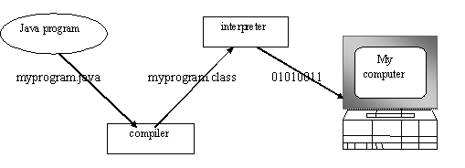
Fig.3.1
You can think of Java byte codes as the machine code instructions for the Java Virtual Machine (JVM). Every Java interpreter, whether it’s a Java development tool or a Web browser that can run Java applets, is an implementation of JVM. That JVM can also be implemented in hardware. Java byte codes help make “write once, run anywhere” possible.
You can compile your Java program into byte codes on any platform that has a Java compiler. The byte codes can then be run on any implementation of the JVm. For example, that same Java program can e run on Windows NT, Solaris and Macintos
Java program
Complier

Interpreter
Interpreter
Interpreter

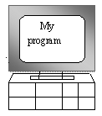
PC-Compatible Sun Ultra Solaris Power macintosh
Windows NT System 8

3.3.1.3 THE JAVA PLATFORM
A platform is the hardware or software environment in which a program runs. The Java platform differs from most other platforms in that it’s a software-only platform that runs on top of other, hardware-based platforms. Most other platforms are described as a combination of hardware and operating system.
The Java platform has two components :
- The Java Virtual Machine (JVM)
- The Java Application Programming Interface (Java API)
You’ve already been introduced to the JVM. It’s the base for the Java platform and is ported onto various hardware-based platforms.
The Java API is a large collection of ready-made software components that provide many useful capabilities, such as graphical user interface (GUI) widgets. The Java API is grouped into libraries (packages) of related components. The following figure depicts a Java program, such as an application or applet, that’s running on the Java platform. As the figure shows, the Java API and Virtual Machine insulates the Java program from hardware dependencies.
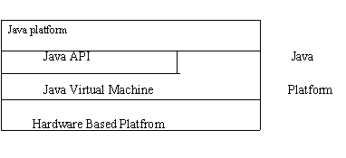
Fig.3.3
As a platform-independent environment, Java can be a bit slower than native code. However, smart compliers, weel-tuned interpreters, and just-in-time byte complilers can bring Java’s performance close to that of native code without threatening protability.

3.5.1.2 WORKING OF JAVA
For those who are new to object-oriented programming, the concept of a class will be new to you. Simplistically, a class is the definition for a segment of code that can contain both data and functions.
When the interpreter executes a class, it looks for a particular method by the name of main, which will sound familiar to C programmers. The main method is passed as a parameter an array of strings (similar to the argv[] of C), and is declared as a static method.
To output text from the program, we execute the println method of System.out, which is java’s output stream. UNIX users will appreciate the theory behind such a stream, as it is actually standard output. For those who are instead used to the Wintel platform, it will write the string passed to it to the user’s program.
3.3.4 APACHE TOMCAT SERVER
Apache Tomcat (formerly under the Apache Jakarta Project; Tomcat is now a top level project) is a web container developed at the Apache Software Foundation. Tomcat implements the servlet and the JavaServer Pages (JSP) specifications from Sun Microsystems, providing an environment for Java code to run in cooperation with a web server. It adds tools for configuration and management but can also be configured by editing configuration files that are normally XML-formatted. Because Tomcat includes its own HTTP server internally, it is also considered a standalone web server.
Environment
Tomcat is a web server that supports servlets and JSPs. Tomcat comes with the Jasper compiler that compiles JSPs into servlets.
The Tomcat servlet engine is often used in combination with an Apache web server or other web servers. Tomcat can also function as an independent web server. Earlier in its development, the perception existed that standalone Tomcat was only suitable for development environments and other environments with minimal requirements for speed and transaction handling. However, that perception no longer exists; Tomcat is increasingly used as a standalone web server in high-traffic, high-availability environments.
Since its developers wrote Tomcat in Java, it runs on any operating system that has a JVM.
Product features
Tomcat 3.x (initial release)
- implements the Servlet 2.2 and JSP 1.1 specifications
- servlet reloading
- basic HTTP functionality Tomcat 4.x
- implements the Servlet 2.3 and JSP 1.2 specifications
- servlet container redesigned as Catalina
- JSP engine redesigned as Jasper
- Coyote connector
- Java Management Extensions (JMX), JSP and Struts-based administration
Tomcat 5.x
- implements the Servlet 2.4 and JSP 2.0 specifications
- reduced garbage collection, improved performance and scalability
- native Windows and Unix wrappers for platform integration
- faster JSP paring
History
Tomcat started off as a servlet specification implementation by James Duncan Davidson, a software architect at Sun. He later helped make the project open source and played a key role in its donation by Sun to the Apache Software Foundation.
Davidson had initially hoped that the project would become open-sourced and, since most open-source projects had O'Reilly books associated with them featuring an animal on the cover, he wanted to name the project after an animal. He came up with Tomcat since he reasoned the animal represented something that could take care of and fend for itself. His wish to see an animal cover eventually came true when O'Reilly published their Tomcat book with a tomcat on the cover

Introduction to Struts
Struts is a open source framework which make building of the web applications easier based on the java Servlet and JavaServer pages technologies.
Struts framework was created by Craig R. McClanahan and donated to the Apache Software Foundation in 2000. The Project now has several committers, and many developers are contributing to overall to the framework.
Developing web application using struts frame work is fairly complex, but it eases things after it is setup. It encourages software development following the MVC design pattern. Many web applications are JSP-only or Servlets-only. With JSP and Servlets, Java code is embedded in the HTML code and the Java code calls println methods to generate the HTML code respectively. Both approaches have their advantages and drawbacks; Struts gathers their strengths to get the best of their association.
Struts is based on Model-View-Controller (MVC) design paradigm, it is an implementation of JSP Model 2 Architecture. For more of Model-View-Controller (MVC) click here.
Consists of 8 Top-Level Packagesand approx 250 Classes and Interfaces.
Struts is a set of cooperating classes, servlets, and JSP tags that make up a reusable MVC 2 design. This definition implies that Struts is a framework, rather than a library, but Struts also contains an extensive tag library and utility classes that work independently of the framework.
The overview of struts
Client browser
An HTTP request from the client browser creates an event. The Web container will respond with an HTTP response.
Controller
The controller is responsible for intercepting and translating user input into actions to
be performed by the model. The controller is responsible for selecting the next view based on user input and the outcome of model operations.The Controller receives the request from the browser, and makes the decision where to send the request. With Struts, the Controller is a command design pattern implemented as a servlet. The struts-config.xml file configures the Controller.
Business logic
The business logic updates the state of the model and helps control the flow of the application. With Struts this is done with an Action class as a thin wrapper to the actual business logic.
Model
A model represents an application’s data and contains the logic for accessing and manipulating that data. Any data that is part of the persistent state of the application should reside in the model objects. The business objects update the application state. ActionForm bean represents the Model state at a session or request level, and not at a persistent level. Model services are accessed by the controller for either querying or effecting a change in the model state. The model notifies the view when a state change occurs in the model.The JSP file reads information from the ActionForm bean using JSP tags.
View
The view is responsible for rendering the state of the model. The presentation semantics are encapsulated within the view, therefore model data can be adapted for several different kinds of clients.The view modifies itself when a change in the model is communicated to the view. A view forwards user input to the controller.The view is simply a JSP file. There is no flow logic, no business logic, and no model information -- just tags. Tags are one of the things that make Struts unique compared to other frameworks like Velocity.
Struts Example
Struts is modeled after the MVC design pattern, you can follow a standard development process for all of your Struts Web applications.
Identificaty of the application Views, the Controller objects that will service those Views, and the Model components being operated on.
1. Define and create all of the Views, in relation to their purpose, that will represent the user interface of our application. Add all ActionForms used by the created Views to the struts-config.xml file.
2. Create the components of the application’s Controller.
3. Define the relationships that exist between the Views and the Controllers (struts-config.xml).
4. Make the appropriate modifications to the web.xml file, describe the Struts components to the Web application.
Lets Start with step one. we will create the view file named index.jsp
index.jsp
<%@ page language="java" %>
<%@ taglib uri="/WEB-INF/struts-html.tld" prefix="html" %>
<html>
<head>
<title>Sample Struts Application</title>
</head>
<body>
<html:form action="Name" name="nameForm" type="example.NameForm">
<table width="80%" border="0">
<tr>
<td>Name:</td>
<td><html:text property="name" /></td>
</tr>
<tr>
<td><html:submit /></td>
</tr>
</table>
</html:form>
</body>
</html>
We have used some Struts-specific Form tag like <html:form /> instead of HTML tags.
In the Form tags the attributes you can find some attributes defined in we will go through it.
action : Represents the URL to which this form will be submitted. This attribute is also used to find the appropriate ActionMapping in the Struts configuration file, which we will describe later in this section. The value used in our example is Name, which will map to an ActionMapping with a path attribute equal to Name.
name :Identifies the key that the ActionForm will be referenced by. We use the value NameForm. An ActionForm is an object that is used by Struts to represent the form data as a JavaBean. It main purpose is to pass form data between View and Controller components. We will discuss NameForm later in this section.
type :Names the fully qualified class name of the form bean to use in this request. For this example, we use thevalue example.NameForm, which is an ActionForm object containing data members matching the inputs of this form.
To use the HTML tags, you must first add a taglib entry in the application’s web.xml file that references the URI /WEB-INF/struts-html.tld. This TLD describes all of the tags in the HTML tag library. The following snippet shows the <taglib> element that must be added to the web.xml file:
<taglib>
<taglib-uri>/WEB-INF/struts-html.tld</taglib-uri>
<taglib-location>/WEB-INF/struts-html.tld</taglib-location>
</taglib>
The struts-html.tld is placed in the /WEB_INF directory.
Next Step is to create the action form
The ActionForm used in this example contains a single data member that maps directly to the name input parameter of the form defined in the index.jsp View. When an <html:form/> is submitted, the Struts framework populates the matching data members of the ActionForm with the values entered into the <html:input/> tags. The Struts framework does this by using JavaBean reflection. The accessors of the ActionForm must follow the JavaBean standard naming convention for example
private String name;
public void setName(String name);
public String getName();
The NameForm.java file is shown below
NameForm.java
package example;
//import statements
import javax.servlet.http.HttpServletRequest;
import org.apache.struts.action.ActionForm;
import org.apache.struts.action.ActionMapping;
public class NameForm extends ActionForm {
private String name = null;
public String getName() {
return (name);
}
public void setName(String name) {
this.name = name;
}
public void reset(ActionMapping mapping, HttpServletRequest request) {
this.name = null;
}
}
To deploy the NameForm to our Struts application, you need to compile this class, move it to the /WEB-INF/classes/example directory, and add the following line to the <form-beans> section of the /WEB-INF/struts-config.xml file:
<form-bean name="nameForm" type="example.NameForm"/>
This makes the Struts application aware of the NameForm and how it should be referenced.
Now we create the out page for the sample application.
Moving to step three, to deploy the NameAction to our Struts application, we need to compile the NameAction class and move the class file to /WEB-INF/classes/example directory, and add the following entry to the <action-mappings> section of the /WEB-INF/struts-config.xml file:
<action path="/Name" type="example.NameAction" name="nameForm" input="/index.jsp">
<forward name="success" path="/displayname.jsp"/>
<forward name="failure" path="/index.jsp"/>
</action>
For step four we modify the web.xml file. We have to to tell the Web application about our ActionServlet. This is accomplished by adding the following servlet definition to the /WEB-INF/web.xml file:
<servlet>
<servlet-name>action</servlet-name>
<servlet-class> org.apache.struts.action.ActionServlet </servlet-class>
<init-param>
<param-name>config</param-name>
<param-value>/WEB-INF/struts-config.xml</param-value>
</init-param>
<load-on-startup>1</load-on-startup>
</servlet>
Once we have told the container about the ActionServlet, we need to tell it when the action should be executed. To do this, we have to add a <servlet-mapping> element to the /WEB-INF/ web.xml file:
<servlet-mapping>
<servlet-name>action</servlet-name>
<url-pattern>*.do</url-pattern>
</servlet-mapping>
You will notice in the previously listed index.jsp that our action does not include a .do at the end of the URL. We do not have to append the .do because it is automatically appended if we use the <html:form /> tag. If you do not use the <html:form /> tag, then you will need to append .do to the action's URL. This mapping tells the Web application that whenever a request is received with .do appended to the URL, the servlet named action should service the request.
Now you are ready to run the application, to begin using this application, you need to open your Web browser to the following URL:
http://localhost:port/example/

Introduction to Servlet
A servlet is a Java programming language class used to extend the capabilities of servers that host applications accessed via a request-response programming model. Although servlets can respond to any type of request, they are commonly used to extend the applications hosted by Web servers. Thus, it can be thought of as a Java Applet that runs on a server instead of a browser.
A Servlet is a Java class in Java EE that conforms to the Java Servlet API, a protocol by which a Java class may respond to requests. They are not tied to a specific client-server protocol, but are most often used with the HTTP protocol. Therefore, the word "Servlet" is often used in the meaning of "HTTP Servlet".Thus, a software developer may use a servlet to add dynamic content to a Web server using the Java platform. The generated content is commonly HTML, but may be other data such as XML. Servlets are the Java counterpart to non-Java dynamic Web content technologies such as CGI and ASP.NET. Servlets can maintain state in session variables across many server transactions by using HTTP cookies, or URL rewriting.
To deploy and run a Servlet, a Web container must be used. A Web container is essentially the component of a Web server that interacts with the servlets. The Web container is responsible for managing the lifecycle of servlets, mapping a URL to a particular servlet and ensuring that the URL requester has the correct access rights.
The servlet API, contained in the Java package hierarchy javax.servlet, defines the expected interactions of the Web container and a servlet
A Servlet is an object that receives a request and generates a response based on that request. The basic servlet package defines Java objects to represent servlet requests and responses, as well as objects to reflect the servlet's configuration parameters and execution environment. The package javax.servlet.http defines HTTP-specific subclasses of the generic servlet elements, including session management objects that track multiple requests and responses between the Web server and a client. Servlets may be packaged in a WAR file as a Web application.
Servlets can be generated automatically from Java Server Pages (JSP) by the JavaServer Pages compiler. The difference between Servlets and JSP is that Servlets typically embed HTML inside Java code, while JSPs embed Java code in HTML. While the direct usage of Servlets to generate HTML (as shown in the example below) is relatively rare nowadays, the higher level MVC web framework in Java EE (JSF) still explicitly uses the Servlet technology for the low level request/response handling via the FacesServlet. A somewhat older usage is to use servlets in conjunction with JSPs in a pattern called "Model 2", which is a flavor of the model-view-controller pattern.
Servlets belong in WEB-INF/classes. On this machine, the source is in Java source in /var/www/hosts/www.caucho.com/webapps/resin-3.0/WEB-INF/classes. WEB-INF/classes is the standard location for servlets and other Java classes. Resin automatically reloads and recompiles servlets, beans, and classes placed in WEB-INF/classes. You should make some changes and add errors to become familiar with Resin's recompilation and the error reporting.
Introduction TO JSP
Java Server Pages or JSP for short is Sun's solution for developing dynamic web sites. JSP provide excellent server side scripting support for creating database driven web applications. JSP enable the developers to directly insert java code into jsp file, this makes the development process very simple and its maintenance also becomes very easy. JSP pages are efficient, it loads into the web servers memory on receiving the request very first time and the subsequent calls are served within a very short period of time.
In today's environment most web sites servers dynamic pages based on user request. Database is very convenient way to store the data of users and other things. JDBC provide excellent database connectivity in heterogeneous database environment. Using JSP and JDBC its very easy to develop database driven web application.
Java is known for its characteristic of "write once, run anywhere." JSP pages are platform independent. Your port your .jsp pages to any platform.

The Life Cycle of a JSP Page
A JSP page services requests as a servlet. Thus, the life cycle and many of the capabilities of JSP pages (in particular the dynamic aspects) are determined by Java Servlet technology and much of the discussion in this chapter refers to functions described in Chapter 10.
When a request is mapped to a JSP page, it is handled by a special servlet that first checks whether the JSP page's servlet is older than the JSP page. If it is, it translates the JSP page into a servlet class and compiles the class. During development, one of the advantages of JSP pages over servlets is that the build process is performed automatically.

Translation and Compilation
During the translation phase, each type of data in a JSP page is treated differently. Template data is transformed into code that will emit the data into the stream that returns data to the client. JSP elements are treated as follows:
- Directives are used to control how the Web container translates and executes the JSP page.
- Scripting elements are inserted into the JSP page's servlet class. See JSP Scripting Elements for details.
- Elements of the form <jsp:XXX ... /> are converted into method calls to JavaBeans components or invocations of the Java Servlet API.
For a JSP page named pageName, the source for a JSP page's servlet is kept in the file
J2EE_HOME/repository/host/web/
context_root/_0002fpageName_jsp.java

For example, the source for the index page (named index.jsp) for the date localization example discussed at the beginning of the chapter would be named
J2EE_HOME/repository/host/web/date/_0002findex_jsp.java

Both the translation and compilation phases can yield errors that are only observed when the page is requested for the first time. If an error occurs while the page is being translated (for example, if the translator encounters a malformed JSP element), the server will return a ParseException, and the servlet class source file will be empty or incomplete. The last incomplete line will give a pointer to the incorrect JSP element.
If an error occurs while the JSP page is being compiled (for example, there is a syntax error in a scriptlet), the server will return a JasperException and a message that includes the name of the JSP page's servlet and the line where the error occurred.
Once the page has been translated and compiled, the JSP page's servlet for the most part follows the servlet life cycle described in the section Servlet Life Cycle:
- If an instance of the JSP page's servlet does not exist, the container:
  - Loads the JSP page's servlet class
  - Instantiates an instance of the servlet class
  - Initializes the servlet instance by calling the jspInit method
- Invokes the _jspService method, passing a request and response object.
If the container needs to remove the JSP page's servlet, it calls the jspDestroy method.

Execution
You can control various JSP page execution parameters using by page directives. The directives that pertain to buffering output and handling errors are discussed here. Other directives are covered in the context of specific page authoring tasks throughout the chapter.

Buffering
When a JSP page is executed, output written to the response object is automatically buffered. You can set the size of the buffer with the following page directive:
<%@ page buffer="none|xxxkb" %>

A larger buffer allows more content to be written before anything is actually sent back to the client, thus providing the JSP page with more time to set appropriate status codes and headers or to forward to another Web resource. A smaller buffer decreases server memory load and allows the client to start receiving data more quickly.

Handling Errors
Any number of exceptions can arise when a JSP page is executed. To specify that the Web container should forward control to an error page if an exception occurs, include the following page directive at the beginning of your JSP page:
<%@ page errorPage="file_name" %>
The Duke's Bookstore application page initdestroy.jsp contains the directive
<%@ page errorPage="errorpage.jsp"%>
The beginning of errorpage.jsp indicates that it is serving as an error page with the following page directive:
<%@ page isErrorPage="true|false" %>

This directive makes the exception object (of type javax.servlet.jsp.JspException) available to the error page, so that you can retrieve, interpret, and possibly display information about the cause of the exception in the error page.
Introduction to Oracle
Where do we start? One of the problems in comprehending a massive product such as the Oracle database is the difficulty of getting a good sense of how the product works without getting lost in the details of implementing specific solutions. This book aims to solve this problem by giving you a thorough grounding in the concepts and technologies that form the foundation of the Oracle Database Server. Oracle also provides an Application Server and business applications, including the E-Business Suite and the Oracle Collaboration Suite,* which are outside the scope of the main body of this book. We’ve tried to write a book for a wide range of Oracle users, from the novice to the experienced user. To address this range of users, we’ve focused on the concepts and technology behind the Oracle database. Once you fully understand these facets of the product, you’ll be able to handle the particulars of virtually any type of Oracle database. Without this understanding, you may feel overburdened as you try to connect the dots of Oracle’s voluminous feature set and documentation.
This first chapter lays the groundwork for the rest of the discussions in this book. Of all the chapters, it covers the broadest range of topics; most of these are discussed further later in the book, but some of the basics—for example, the brief history of Oracle and the contents of the different “flavors” of the Oracle database products are unique to this chapter.
Oracle has grown from its humble beginnings as one of a number of databases available in the 1970s to the market leader of today. In its early days, Oracle Corporation was known more as an aggressive sales and promotion organization than a technology supplier. Over the years, the Oracle database has grown in depth and quality, and its technical capabilities now are generally recognized as the most advanced. With each release, Oracle has added more power and features to its already solid base while improving the manageability.
Oracle8i
Oracle8i, released in 1999, added a new twist to the Oracle database—a combination of enhancements that made the Oracle8i database the focal point of the world of Internet (the i in 8i) computing.

Oracle9i
Oracle9i, released in 2001, introduced Real Application Clusters as a replacement for Oracle Parallel Server, and added many management and data warehousing features.

Oracle Database 10g
Oracle Database 10g, released in 2003 and the current release, enables grid (the g in 10g) computing. A grid is simply a pool of computers that provides needed resources for applications on an as-needed basis. The goal is to provide computing resources that transparently scale to the user community, much as an electrical utility company can deliver power to meet peak demand by accessing energy from other power providers’ plants via a power grid. Oracle Database 10g further reduces the time, cost, and complexity of database management through the introduction of self-managing features such as the Automated Database Diagnostic Monitor, Automated Shared Memory Tuning, Automated Storage Management, and Automated Disk Based Backup and Recovery. One important key to Oracle Database 10g’s usefulness in grid computing is the ability to provision
CPUs and data.
Before we dive into the specific foundations of these releases, we must spend a little time describing some Oracle basics—how databases evolved to arrive at the relational model, a brief history of Oracle Corporation, and an introduction to the basic features and configurations of the database.

The Oracle Family
Oracle Database 10g Database Server describes the most recent major version of the Oracle Relational Database Management System (RDBMS) family of products that share common source code. This family includes:
- Personal Oracle, a database for single users that’s often used to develop code for implementation on other Oracle multiuser databases
- Oracle Standard Edition, which was named Workgroup Server in its first iteration
as part of the Oracle7 family and is sometimes simply referred to as Oracle Server
- Oracle Enterprise Edition, which includes all Standard Edition functionality and additional functionality
- Oracle Lite, used primarily for mobile applications

Oracle8 was introduced in 1997 with larger size limitations and management features, such as partitioning, aimed at very large database implementations. In 1998, Oracle announced Oracle8i, which is sometimes referred to as Version 8.1 of the Oracle8 database. The i was added to denote added functionality supporting Internet deployment in the new version. Oracle9i followed, with Application Server available in 2000 and Database Server in 2001. Oracle Database 10g was introduced in 2003; the g denotes Oracle’s focus on emerging grid deployment models. The terms Oracle, Oracle8, Oracle8i, Oracle9i and Oracle Database 10g (or Oracle10g) might appear to be used somewhat interchangeably in this book, because Oracle Database 10g includes all the features of previous versions. When we describe a new feature that was first made available specifically in certain releases, we’ve tried to note that fact to avoid confusion, recognizing that many of you may have old releases of Oracle. We typically use the simple term Oracle when describing features that are common to all these releases.
Oracle has focused development around a single source code model since 1983. While each database implementation includes some operating system–specific source code at very low levels in order to better leverage specific platforms, the interfaces that users, developers, and administrators deal with for each version are consistent. Because features are consistent across platforms for implementations of Oracle Standard Edition and Oracle Enterprise Edition, companies can migrate Oracle applications easily to various hardware vendors and operating systems while leveraging their investments in Oracle technology. This development strategy also enables Oracle to focus on implementing new features only once in its product set, instead of having to add functionality at different times to different implementations.

Oracle Standard Edition
Oracle Standard Edition refers to a specific database offering, once known as Workgroup Server. From a functionality and pricing standpoint, this product intends to compete in the entry-level multiuser and small database category, supporting smaller numbers of users. These releases are available today on Windows and Unix platforms such as HP Compaq, HP/UX, IBM AIX, Linux, and Sun Solaris.

Oracle Enterprise Edition
Oracle Enterprise Edition is aimed at larger-scale implementations that require additional features. Enterprise Edition is available on far more platforms than the Oracle release for workgroups and includes advanced management, networking, programming, and data warehousing features, as well as a variety of special-purpose options, such as clustering, which are available at extra cost.
This is the Title of the Book, eMatter Edition
Copyright © 2004 O’Reilly & Associates, Inc. All rights reserved.
Oracle Personal Edition
Oracle Personal Edition is the single-user version of Oracle Enterprise Edition. Personal Edition is most frequently used for development on a single machine. Because the features match those of Enterprise Edition, a developer can write applications using the Personal Edition and deploy them to multi-user servers. Some companies deploy single-user applications using this product. However, Oracle Lite offers a much more lightweight means of deploying the same applications.
Oracle Lite
Oracle Lite, once known as Oracle Mobile, is intended for single users who are using wireless/mobile devices. It differs from other members of the Oracle database family in that it doesn’t use the same database engine. Instead, Oracle developed a lightweight engine compatible with the limited memory and storage capacity of handheld devices. Oracle Lite is described in more detail at the end of this chapter. Because the SQL supported by Oracle Lite is largely the same as the SQL for other Oracle databases, you can run applications developed for those database engines using Oracle Lite. Replication of data between Oracle Lite and other Oracle versions is a key part of most implementations. Table 1-2 summarizes the situations in which you would typically use each database product. We’ve used the Oracle product names to refer to the different members of the Oracle database family.

Java features and options
Oracle8i introduced the use of Java as a procedural language with a Java Virtual Machine (JVM) in the database (originally called JServer). JVM includes support for Java stored procedures, methods, triggers, Enterprise JavaBeans™ (EJBs), CORBA, and HTTP. The Accelerator is used for project generation, translation, and compilation, and can also be used to deploy/install shared libraries. The inclusion of Java within the Oracle database allows Java developers to leverage their skills as Oracle application developers. Java applications can be deployed in the client, Application Server, or database, depending on what is most appropriate. Oracle data warehousing options for OLAP and data mining provide a Java API. These applications are typically custom built using Oracle’s JDeveloper.
XleTView
A multimedia home platform, or MPH, is an interactive digital television middleware system that allows the reception and execution of interactive Java applications on a television set. Interactive television, also known as ITV, enables people to not only view television but also interact with its content. The activities that users can interact with include information services, games, voting, e-mail, SMS or shopping. MHP applications may make use of an additional return channel that supports Internet Protocol.
MPH comes in two presentations, DVB-HTML applications and the more popular DVB-J applications, also known as Xlets. An Xlet interface allows an external source to initiate and halt an application. This ability is crucial for a set-top box environment, which in turn is an essential component of interactive television.
Xlets usually require a brief manual on how to install the software and how it works. It describes details about the latest version of the software, the 0.3.6., although there have been plans to change the features and how they work.<br /><br />The manual typically talks about the directory structure one should get when downloading and unzipping the file, about how to start the software, how to run it, about the remote control, the shortcut keys and the settings file. The information is meant to help any new user to start using the emulator, but more information can also be found online, especially related to components and troubleshooting any problems.
Configuring XleTView
Configuring the channels that are available
Any TV will have a list of channels available, and XleTView also offers this functionality. Unlike a real TV, you need to tell it what channels are available and you can do this by editing the config/channels.xmlfile. The default version of this file looks like this:

<?xml version="1.0" encoding="ISO-8859-1"?>
<CHANNELS>
<CHANNEL>
<NAME>0</NAME>
<MEDIA>config/defaultbg.jpg</MEDIA>
</CHANNEL>
</CHANNELS>

As you can see, each channel definition consists of two parts. The < NAME> element contains the channel name or number that will be assigned to this channel. The
< MEDIA> element tells.
XleTView what it should display in the background when that channel is selected. This can either be a JPEG image (which should be 720 pixels wide by 576 pixels high) or it can be an AVI file if you prefer a moving background. Please note that only some types of AVI file are supported - see the section on using video with XleTView for more details.
When you first start XleTView, it will display the channel listed first in the channels.xml file. In version 0.3.6 of XleTView it is not possible to change the channel using the keys on the remote.

- Introduction

  - Purpose

The mainstay of this project is to describe a system based on virtual trip lines and an associated cloaking technique, in which we relax the privacy requirements to maximize the accuracy of real-time traffic estimation.
The location updates are done based on 2 processes:
- Location Updates based on Trip Line Id.
- Speed Updates

Project Scope
Traffic monitoring using probe vehicles with GPS receivers promises significant improvements in cost, coverage, and accuracy over dedicated infrastructure systems. Current approaches, however, raise privacy concerns because they require participants to reveal their positions to an external traffic monitoring server.

We describe a system based on virtual trip lines and an associated cloaking technique, in which we relax the privacy requirements to maximize the accuracy of real-time traffic estimation. We introduce virtual trip lines which are geographic markers that indicate where vehicles should provide speed updates. These markers are placed to avoid specific privacy sensitive locations. They also allow aggregating and cloaking several location updates based on trip line identifiers, without knowing the actual geographic locations of these trip lines. Thus, they facilitate the design of a distributed architecture, in which no single entity has a complete knowledge of probe identities and fine-grained location information.
- Overall Description

  - Product Perspective

Location Updates based on Time was the main feature which was concentrated in our existing system. We propose a new technique by which we monitor the user updates based on Location Updates.
We propose k-anonymity by which we maintain 3-level authentication process. A user makes an initial level registration gets authorized with our application. Whenever he starts to update his location based on his GPS facility in his mobile, we go through this 3 stage level of authentication processes. First, the user requests an authentication id to the VTL Generator via a Proxy Server. The VTL Generator provides him a key for the user as an initial authentication process. The key is then forwarded by the user in return to the VTL Generator which in turn forwards a One Time Password for the user’s mobile phone to validate the user. The VTL Generator stores the encrypted key (one time password) and when the user updates his information, the server uses the key to decrypt the content. All the updates from the user are processed via a Proxy Server such as all information must not be stored under a single party. An authentication level validation will be done at the Proxy End also.
  - Product Features

Traffic monitoring using probe vehicles with GPS receivers promises significant improvements in cost, coverage, and accuracy over dedicated infrastructure systems. Current approaches, however, raise privacy concerns because they require participants to reveal their positions to an external traffic monitoring server.

We describe a system based on virtual trip lines and an associated cloaking technique, in which we relax the privacy requirements to maximize the accuracy of real-time traffic estimation. We introduce virtual trip lines which are geographic markers that indicate where vehicles should provide speed updates. These markers are placed to avoid specific privacy sensitive locations. They also allow aggregating and cloaking several location updates based on trip line identifiers, without knowing the actual geographic locations of these trip lines. Thus, they facilitate the design of a distributed architecture, in which no single entity has a complete knowledge of probe identities and fine-grained location information.
Our scheme has several advantages:
1) We implement Virtual Trip Lines based Global Positioning System to track the customer’s current position.
2) We propose a distributed VTL-based temporal cloaking scheme that reduces time stamp accuracy to guarantee a degree of k-anonymity in the data set accumulated at the VTL server.
3) We propose an advanced scheme by which we provide an HashD for each and every unique user passing through the corresponding region.

  - User Classes and Characteristics
Package: com.jsp.*; package source files are used for presentation and result viewing page.
Package: com.database.DbConnection.java source file is used to establish the connection to the database and data warehouse and execute the sql Prepared Statements as a predefined procedure.
Package: com.* file is used to implement out the entire concepts of the project. All classes, mapping files, xml files are included in this package.
Vehicle Users – The Vehicle User uses the highway, authenticates with the VTL Generator, receives an id. and forwards his GPS Positions to the server.
VTL Generator – The VTL Generator generates an authentication id. for each and every user and forwards the various trip line information to the vehicle user.
VTL Server – The VTL Server receives the GPS information sent from the user’s, authenticates and calculates the mean speed between each and every trip line and terminates the fake user from the network..
Proxy Server – The Proxy Server acts as an intermediator, forwards the information from the user to the VTL Generator/ VTL Server, and authenticates user identities for each and every process.

2.4 Design and Implementation Constraints

2.5.1 Constraints in Analysis
- Constraints as Informal Text
- Constraints as Operational Restrictions
- Constraints Integrated in Existing Model Concepts
- Constraints as a Separate Concept
- Constraints Implied by the Model Structure

2.5.2 Constraints in Design
- Determination of the Involved Classes
- Determination of the Involved Objects
- Determination of the Involved Actions
- Determination of the Require Clauses
- Global actions and Constraint Realization

2.5.3 Constraints in Implementation
A hierarchical structuring of relations may result in more classes and a more complicated structure to implement. Therefore it is advisable to transform the hierarchical relation structure to a simpler structure such as a classical flat one. It is rather straightforward to transform the developed hierarchical model into a bipartite, flat model, consisting of classes on the one hand and flat relations on the other. Flat relations are preferred at the design level for reasons of simplicity and implementation ease. There is no identity or functionality associated with a flat relation. A flat relation corresponds with the relation concept of entity-relationship modeling and many object oriented methods.

- System Features

We propose a novel traffic monitoring system design based on the concept of Virtual Trip Lines (VTLs) and experimentally evaluate its feasibility. Virtual trip lines are geographic markers stored in the mobile phone client, which trigger a position and speed update when a probe vehicle trajectory intersects a trip line. Through privacy-aware placement of these trip lines, clients need not rely on a trustworthy server. The system is designed for GPS-enabled cell phones to enable rapid software deployment to a large and increasing number of programmable smart phones.
The VTL concept can be extended to provide several additional benefits.
Allows system designers to choose several different options for privacy protection.
For a given number of location updates from drivers, the VTL paradigm allows system designers to predefine measurement locations for high-value updates.
The use of VTLs removes the need for map matching the measurement update to road segments, since each VTL is already associated with a road segment.
System designers can embed traffic alerts or warnings on VTLs by piggybacking on the system’s acknowledgment packet which responds to a user’s location update.
We can define a timer attribute for each VTL which specifies the allowable latency for each measurement.
We can dynamically turn On/Off VTLs depending on the time of day and congestion levels.

- External Interface Requirements

  - User Interfaces

1. All the contents in the project are implemented using Graphical User Interface (GUI) jsp and html pages.
2. Every conceptual part of the projects is reflected using the jsp and html.
3. System gets the input and delivers through the GUI based.

  - Hardware Interfaces

4.1.1 Ethernet
Ethernet on the AS/400 supports TCP/IP, Advanced Peer-to-Peer Networking (APPN) and advanced program-to-program communications (APPC).

4.1.2ISDN
You can connect your AS/400 to an Integrated Services Digital Network (ISDN) for faster, more accurate data transmission. An ISDN is a public or private digital communications network that can support data, fax, image, and other services over the same physical interface. Also, you can use other protocols on ISDN, such as IDLC and X.25.

  - Software Interfaces
This software is interacted with the Http protocol. This protocol is running in tomcat port number (default 80).
Communication Interfaces
1. Http Protocol.
2. LAN Settings.

- Other Nonfunctional Requirements

  - Performance Requirements

We propose k-anonymity by which we maintain 3-level authentication process.
A user makes an initial level registration gets authorized with our application.
Whenever he starts to update his location based on his GPS facility in his mobile, we go through this 3 stage level of authentication processes. First, the user requests an authentication id to the VTL Generator via a Proxy Server. The VTL Generator provides him a key for the user as an initial authentication process. The key is then forwarded by the user in return to the VTL Generator which in turn forwards a One Time Password for the user’s mobile phone to validate the user. The VTL Generator stores the encrypted key (one time password) and when the user updates his information, the server uses the key to decrypt the content. All the updates from the user are processed via a Proxy Server such as all information must not be stored under a single party. An authentication level validation will be done at the Proxy End also.
The location updates are done based on 2 processes:
- Location Updates based on Trip Line Id.
- Speed Updates
The server monitors the moving user in his screen and calculates the speed updates updated by several vehicles on the lane. He also discards the user who stays in a particular location for a longer period.
The technologies we have used is Java, Jsp, Servlets, Ajax, Struts, Android. Tomcat will be the Server in which we deploy our project and Oracle will be our Back End.

  - Safety Requirements

1. The software may be safety-critical. If so, there are issues associated with its integrity level.
2. The software may not be safety-critical although it forms part of a safety-critical system. For example, software may simply log transactions.
3. If a system must be of a high integrity level and if the software is shown to be of that integrity level, then the hardware must be at least of the same integrity level.
4. There is little point in producing 'perfect' code in some language if hardware and system software (in widest sense) are not reliable.
5. If a computer system is to run software of a high integrity level then that system should not at the same time accommodate software of a lower integrity level.
6. Systems with different requirements for safety levels must be separated.
7. Otherwise, the highest level of integrity required must be applied to all systems in the same environment.
  - Security Requirements
Do not block the some available ports through the windows firewall
5.4 Software Quality Attributes
Functionality: are the required functions available, including Interoperability and security
Reliability: maturity, fault tolerance and recoverability
Usability: how easy it is to understand, learn, and operate the software System
Efficiency: performance and resource behavior.
Maintainability: Maintaining the software.
Portability: can the software easily be transferred to another environment,
Including install ability
CHAPTER 4

Architecture:
VTL Updates /Download

VTL
Generator

Traffic Monitoring
Service Provider

VTL
Server
Proxy Server

Client
Encrypted RPC / Traffic Estimation
TL Database, Update Log

Fig: 4.1
4.1 Sequence Diagram:
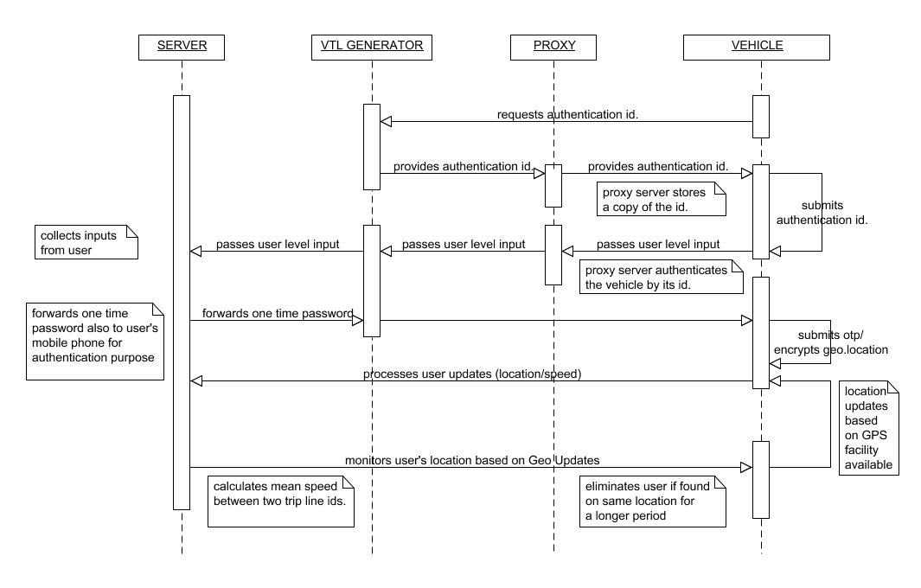

4.2 Use Case Diagram:
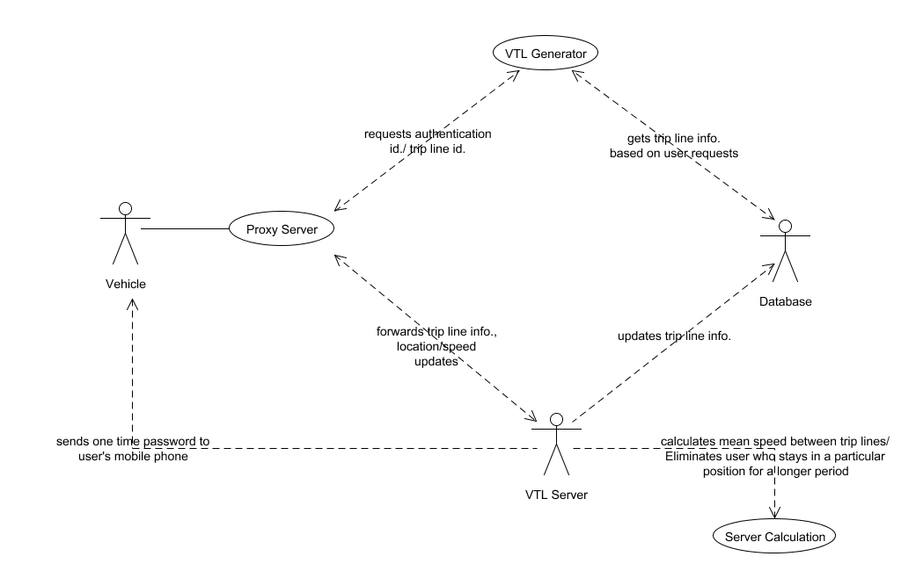

4.3 Activity Diagram:
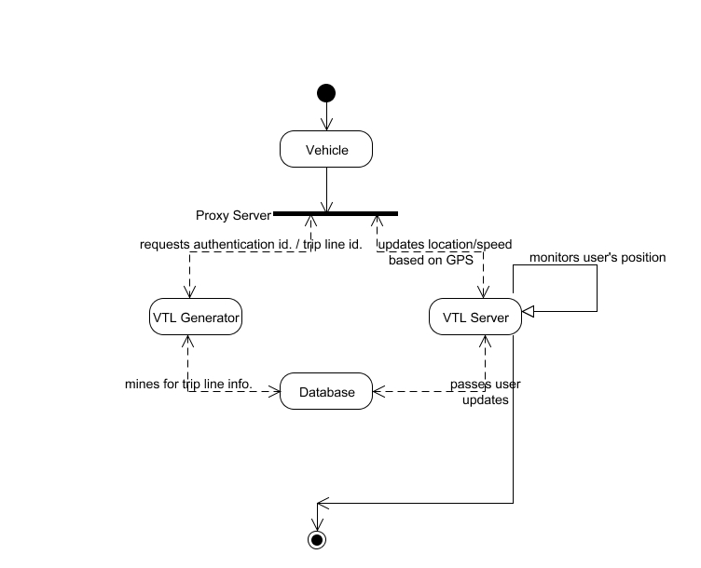

Collaboration Diagram:
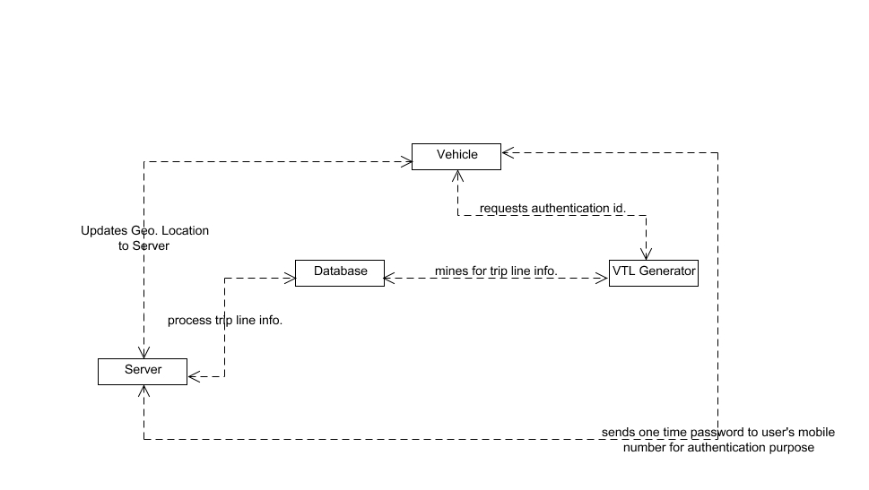

DATA FLOW DIAGRAM:

Level 0:

DATABASE

VEHICLE

GENERATOR

Registration
via Proxy

Level 1:

DATABASE

VEHICLE

GENERATOR

Authentication Id.
Issues VTL Info.

Level 2:

DATABASE

VEHICLE

GENERATOR

One Time Password.
via Proxy Server

Level 3:

DATABASE

DATABASE

CUSTOMER

WAITER

VEHICLE

GENERATOR

Proxy Server

SERVER
Updates Trip Line Info.,
GPS Positions, Authentication Id.

Level 4:

DATABASE

DATABASE

CUSTOMER

WAITER

VEHICLE

GENERATOR

Proxy Server

SERVER
Updates Speed Information

Level 5:

DATABASE

DATABASE

CUSTOMER

WAITER

VEHICLE

GENERATOR

Proxy Server

SERVER
Updates Speed Information

Calculates Mean Speed,
Eliminates Fake U

Class Diagram

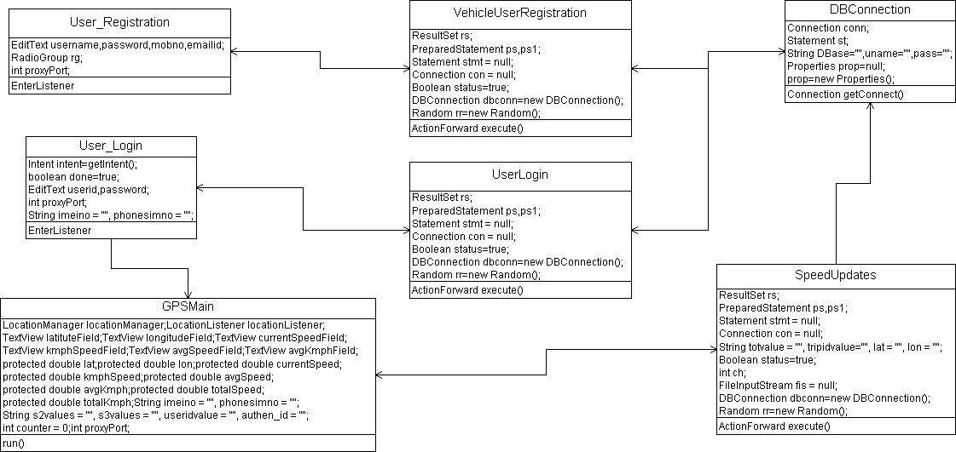

CHAPTER 5

SYSTEM DESIGN
5.1 MODULES
- VTL Upload and Client Registration via Proxy
- Authentication ID and One-Time Password Generation
- Trip Line ID, Location Updates
- Speed Updates, Calculation of Mean Speed

5.2 MODULE EXPLANATION:

VTL Upload and Client Registration via Proxy

A virtual trip line is a line segment in geographic space that, when crossed, triggers a client’s location update to the traffic monitoring server. The admin uploads the various latitude and longitude positions, stores them in the database and allots the TRIP LINE ID for selected positions.
The client has an initial level registration process in our application via a Proxy Server. The Server generates a User Id for the corresponding drivers for a login purpose.

Authentication ID and One-Time Password Generation

The clients switch on to our application once they start to drive their vehicles. A requisition is made where the server generates an authentication id for the corresponding clients. A copy of the id is stored in the proxy for each client to prevent unauthorized measurements and then forward anonymized measurements to the VTL server. Again a one time password is generated and sent to the client’s mobile phone, where the client forwards the one time password to VTL Server for further authentication.

Trip Line ID, Location Updates

Each VTL has an expiration time beyond which its ID becomes invalid. Our system allows the user to renew its Trip Line Id. after its expiration. The application starts to roll-on the client’s mobile where the user’s current GPS positions are tracked by the server. The location updates are monitored by the server when the user crosses each trip line.

Speed Updates, Calculation of Mean Speed

Along with the identification information, the client also updates his sensing measurements (in this case it’s the client’s moving speed) with different keys, where we prevent each entity from observing both the identification and the sensing measurements. The mean averages between trip lines are calculated by the VTL server for further speed updates.

CHAPTER 6
CODING AND TESTING
6.1 CODING
Once the design aspect of the system is finalizes the system enters into the coding and testing phase. The coding phase brings the actual system into action by converting the design of the system into the code in a given programming language. Therefore, a good coding style has to be taken whenever changes are required it easily screwed into the system.

6.2 CODING STANDARDS
Coding standards are guidelines to programming that focuses on the physical structure and appearance of the program. They make the code easier to read, understand and maintain. This phase of the system actually implements the blueprint developed during the design phase. The coding specification should be in such a way that any programmer must be able to understand the code and can bring about changes whenever felt necessary. Some of the standard needed to achieve the above-mentioned objectives are as follows:
Program should be simple, clear and easy to understand.
Naming conventions
Value conventions
Script and comment procedure
Message box format
Exception and error handling
6.2.1 NAMING CONVENTIONS
Naming conventions of classes, data member, member functions, procedures etc., should be self-descriptive. One should even get the meaning and scope of the variable by its name. The conventions are adopted for easy understanding of the intended message by the user. So it is customary to follow the conventions. These conventions are as follows:
Class names
Class names are problem domain equivalence and begin with capital letter and have mixed cases.
Member Function and Data Member name
Member function and data member name begins with a lowercase letter with each subsequent letters of the new words in uppercase and the rest of letters in lowercase.
6.2.2 VALUE CONVENTIONS
Value conventions ensure values for variable at any point of time. This involves the following:
- Proper default values for the variables.
- Proper validation of values in the field.
- Proper documentation of flag values.

6.2.3 SCRIPT WRITING AND COMMENTING STANDARD
Script writing is an art in which indentation is utmost important. Conditional and looping statements are to be properly aligned to facilitate easy understanding. Comments are included to minimize the number of surprises that could occur when going through the code.
6.2.4 MESSAGE BOX FORMAT
When something has to be prompted to the user, he must be able to understand it properly. To achieve this, a specific format has been adopted in displaying messages to the user. They are as follows:
- X – User has performed illegal operation.
- ! – Information to the user.
6.3 TEST PROCEDURE
SYSTEM TESTING
Testing is performed to identify errors. It is used for quality assurance. Testing is an integral part of the entire development and maintenance process. The goal of the testing during phase is to verify that the specification has been accurately and completely incorporated into the design, as well as to ensure the correctness of the design itself. For example the design must not have any logic faults in the design is detected before coding commences, otherwise the cost of fixing the faults will be considerably higher as reflected. Detection of design faults can be achieved by means of inspection as well as walkthrough.
Testing is one of the important steps in the software development phase. Testing checks for the errors, as a whole of the project testing involves the following test cases:
- Static analysis is used to investigate the structural properties of the Source code.
- Dynamic testing is used to investigate the behavior of the source code by executing the program on the test data.

6.4 TEST DATA AND OUTPUT
6.4.1 UNIT TESTING
Unit testing is conducted to verify the functional performance of each modular component of the software. Unit testing focuses on the smallest unit of the software design (i.e.), the module. The white-box testing techniques were heavily employed for unit testing.

6.4.2 FUNCTIONAL TESTS
Functional test cases involved exercising the code with nominal input values for which the expected results are known, as well as boundary values and special values, such as logically related inputs, files of identical elements, and empty files.
Three types of tests in Functional test:
- Performance Test
- Stress Test
- Structure Test

6.4.3 PERFORMANCE TEST
It determines the amount of execution time spent in various parts of the unit, program throughput, and response time and device utilization by the program unit.

6.4.4 STRESS TEST
Stress Test is those test designed to intentionally break the unit. A Great deal can be learned about the strength and limitations of a program by examining the manner in which a programmer in which a program unit breaks.
6.4.5 STRUCTURED TEST
Structure Tests are concerned with exercising the internal logic of a program and traversing particular execution paths. The way in which White-Box test strategy was employed to ensure that the test cases could Guarantee that all independent paths within a module have been have been exercised at least once.
- Exercise all logical decisions on their true or false sides.
- Execute all loops at their boundaries and within their operational bounds.
- Exercise internal data structures to assure their validity.
- Checking attributes for their correctness.
- Handling end of file condition, I/O errors, buffer problems and textual errors in output information
6.4.6 INTEGRATION TESTING
Integration testing is a systematic technique for construction the program structure while at the same time conducting tests to uncover errors associated with interfacing. i.e., integration testing is the complete testing of the set of modules which makes up the product. The objective is to take untested modules and build a program structure tester should identify critical modules. Critical modules should be tested as early as possible. One approach is to wait until all the units have passed testing, and then combine them and then tested. This approach is evolved from unstructured testing of small programs. Another strategy is to construct the product in increments of tested units. A small set of modules are integrated together and tested, to which another module is added and tested in combination. And so on. The advantages of this approach are that, interface dispenses can be easily found and corrected.
The major error that was faced during the project is linking error. When all the modules are combined the link is not set properly with all support files. Then we checked out for interconnection and the links. Errors are localized to the new module and its intercommunications. The product development can be staged, and modules integrated in as they complete unit testing. Testing is completed when the last module is integrated and tested.
6.5 TESTING TECHNIQUES / TESTING STRATERGIES
6.5.1 TESTING
Testing is a process of executing a program with the intent of finding an error. A good test case is one that has a high probability of finding an as-yet –undiscovered error. A successful test is one that uncovers an as-yet- undiscovered error. System testing is the stage of implementation, which is aimed at ensuring that the system works accurately and efficiently as expected before live operation commences. It verifies that the whole set of programs hang together. System testing requires a test consists of several key activities and steps for run program, string, system and is important in adopting a successful new system. This is the last chance to detect and correct errors before the system is installed for user acceptance testing.
The software testing process commences once the program is created and the documentation and related data structures are designed. Software testing is essential for correcting errors. Otherwise the program or the project is not said to be complete. Software testing is the critical element of software quality assurance and represents the ultimate the review of specification design and coding. Testing is the process of executing the program with the intent of finding the error. A good test case design is one that as a probability of finding an yet undiscovered error. A successful test is one that uncovers an yet undiscovered error. Any engineering product can be tested in one of the two ways:

6.5.1.1 WHITE BOX TESTING
This testing is also called as Glass box testing. In this testing, by knowing the specific functions that a product has been design to perform test can be conducted that demonstrate each function is fully operational at the same time searching for errors in each function. It is a test case design method that uses the control structure of the procedural design to derive test cases. Basis path testing is a white box testing.
Basis path testing:
- Flow graph notation
- Cyclometric complexity
- Deriving test cases
- Graph matrices Control

6.5.1.2 BLACK BOX TESTING
In this testing by knowing the internal operation of a product, test can be conducted to ensure that “all gears mesh”, that is the internal operation performs according to specification and all internal components have been adequately exercised. It fundamentally focuses on the functional requirements of the software.
The steps involved in black box test case design are:
- Graph based testing methods
- Equivalence partitioning
- Boundary value analysis
- Comparison testing
6.5.2 SOFTWARE TESTING STRATEGIES:
A software testing strategy provides a road map for the software developer. Testing is a set activity that can be planned in advance and conducted systematically. For this reason a template for software testing a set of steps into which we can place specific test case design methods should be strategy should have the following characteristics:
- Testing begins at the module level and works “outward” toward the integration of the entire computer based system.
- Different testing techniques are appropriate at different points in time.
- The developer of the software and an independent test group conducts testing.
- Testing and Debugging are different activities but debugging must be accommodated in any testing strategy.

6.5.2.1 INTEGRATION TESTING:
Integration testing is a systematic technique for constructing the program structure while at the same time conducting tests to uncover errors associated with. Individual modules, which are highly prone to interface errors, should not be assumed to work instantly when we put them together. The problem of course, is “putting them together”- interfacing. There may be the chances of data lost across on another’s sub functions, when combined may not produce the desired major function; individually acceptable impression may be magnified to unacceptable levels; global data structures can present problems.

6.5.2.2 PROGRAM TESTING:
The logical and syntax errors have been pointed out by program testing. A syntax error is an error in a program statement that in violates one or more rules of the language in which it is written. An improperly defined field dimension or omitted keywords are common syntax error. These errors are shown through error messages generated by the computer. A logic error on the other hand deals with the incorrect data fields, out-off-range items and invalid combinations. Since the compiler s will not deduct logical error, the programmer must examine the output. Condition testing exercises the logical conditions contained in a module. The possible types of elements in a condition include a Boolean operator, Boolean variable, a pair of Boolean parentheses A relational operator or on arithmetic expression. Condition testing method focuses on testing each condition in the program the purpose of condition test is to deduct not only errors in the condition of a program but also other a errors in the program.

6.5.2.3 SECURITY TESTING:
Security testing attempts to verify the protection mechanisms built in to a system well, in fact, protect it from improper penetration. The system security must be tested for invulnerability from frontal attack must also be tested for invulnerability from rear attack. During security, the tester places the role of individual who desires to penetrate system.
6.5.2.4 VALIDATION TESTING
At the culmination of integration testing, software is completely assembled as a package. Interfacing errors have been uncovered and corrected and a final series of software test-validation testing begins. Validation testing can be defined in many ways, but a simple definition is that validation succeeds when the software functions in manner that is reasonably expected by the customer. Software validation is achieved through a series of black box tests that demonstrate conformity with requirement. After validation test has been conducted, one of two conditions exists.
* The function or performance characteristics confirm to specifications and are accepted.
* A validation from specification is uncovered and a deficiency created.
Deviation or errors discovered at this step in this project is corrected prior to completion of the project with the help of the user by negotiating to establish a method for resolving deficiencies. Thus the proposed system under consideration has been tested by using validation testing and found to be working satisfactorily. Though there were deficiencies in the system they were not catastrophic
6.5.2.5 USER ACCEPTANCE TESTING
User acceptance of the system is key factor for the success of any system. The system under consideration is tested for user acceptance by constantly keeping in touch with prospective system and user at the time of developing and making changes whenever required. This is done in regarding to the following points.
- Input screen design.
- Output screen design.

Source Code

Screenshots:

REFERENCES

[1] http://traffic.berkeley.edu, 2011.

[2] http://www.fcc.gov/Bureaus/Wireless, 2011.

[3] http://www.paramics-online.com, 2011.

4] http://www.privacyrights.org/ar/ChronDataBreaches.htm,2011.

[5] TeleNav, http://www.telenav.net, 2004.

[6] Inrix, http://www.inrix.com, 2006.

[7] Google Maps, http://www.google.com/mobile/maps, 2011.

[8] Waze, http://www.waze.com, 2009.

[9] A. Beresford and F. Stajano, “Mix Zones: User Privacy in Location-Aware Services,” Proc. IEEE Ann. Conf. Pervasive Computing and Comm. Workshop, 2004.

[10] C. Claudel and A.A. Bayen, “Lax-Hopf Based Incorporation of Internal Boundary Conditions into Hamilton-Jacobi Equation. Part II: Computational Methods,” IEEE Trans. Automatic Control, vol. 55, no. 5, pp. 1158-1174, May 2010.

[11] C. Claudel and A. Bayen, “Lax-hopf Based Incorporation of Internal Boundary Conditions into Hamilton-Jacobi Equation. Part I: Theory,” IEEE Trans. Automatic Control, vol. 55, no. 5, pp. 1142-1157, May 2010.

[12] X. Dai, M. Ferman, and R. Roesser, “A Simulation Evaluation of a Real-Time Traffic Information System Using Probe Vehicles,”Proc. IEEE Intelligent Transportation Systems (ITS), pp. 475-480, Oct.2003.

[13] G. Evensen, Data Assimilation: The Ensemble Kalman Filter. Springer-Verlag, 2007.

[14] M. Ferman, D. Blumenfeld, and X. Dai, “A Simple Analytical Model of a Probe-Based Traffic Information System,” Proc. IEEE Intelligent Transportation Systems (ITS), pp. 263-268, 2003.

[15] C. Furtlehner, J.M. Lasgouttes, and A.D.L. Fortelle, “A Belief Propagation Approach to Traffic Prediction Using Probe Vehicles,” Proc. IEEE Intelligent Transportation Systems (ITS) Conf., pp. 1022-1027, 2007.

